Debate WebApp manual test plan:

1. go to the index page
   1. Make sure it has 3 buttons that allow you to start, view and join a debate
   2. Should look like this:
2. Click on the start button
   1. Should have options for setting up the debate
   2. Should look like this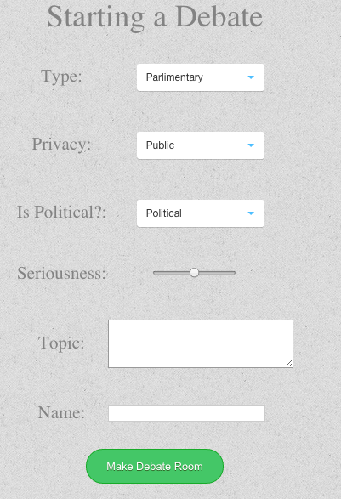
3. Click on the make debate room button
   1. Should lead to the debate page
   2. The debate page looks like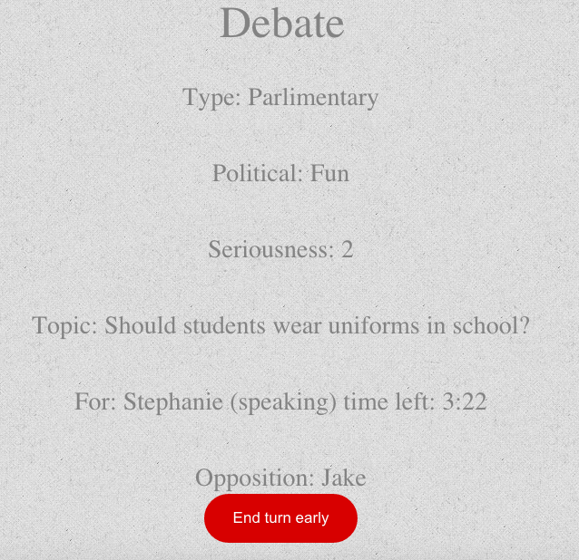
4. Go back to the main page and click on the view button
   1. The view button should show you a list of the publicly viewable debates
   2. It should allow you to click on one of those debates and go to the debates page
   3. It should look like this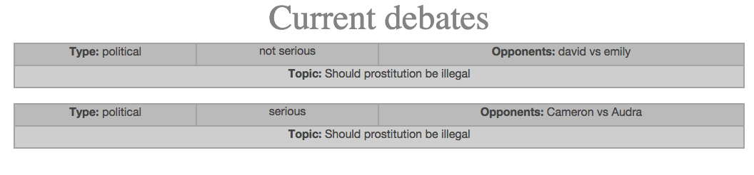
5. Go back to the main page and click on the Join button
   1. It should show you a list of joinable debates
   2. When you click on one it should go to the debates page
   3. It should look like this: 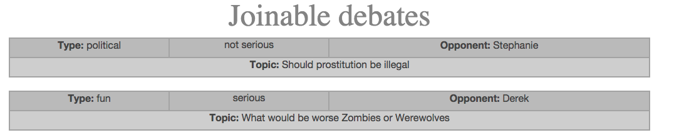
6. What you should see
   1. When you have created a debate and had a friend join it you should have audio-video switch between the two of you every 10 seconds
   2. When you view the debate you should be able to see it switch between the debators every 10 seconds.